Document Type: INFORMATIONAL

Title: FAQ-How to Install Microsoft SQL Express 2008 R2

Question: How do I install Microsoft SQL Express 2008 R2?

Product:
Product: Sage Fund Accounting
Module: System Manager
Version/SP: 11.00 and higher
KB #: 318438

Environment:
Third Party: Microsoft Sql Server Express 2008 R2

Solution:

Note: When utilizing Microsoft Windows Server 2012 operating system, it will be necessary to apply at least Service Pack 1 (SP2 will work) for the SQL environment to avoid incompatibility issues. Also note, this update may or may not be available automatically with windows updates.

First, you must determine whether you have a 64 bit or 32 bit computer using the Microsoft System Information. Click start | run or Windows Key + R to spawn the run dialog, then enter msinfo32 as displayed in the graphic below. Msinfo32 is present on all versions of Windows ( Windows XP to Windows Server 2008 R2 inclusive)

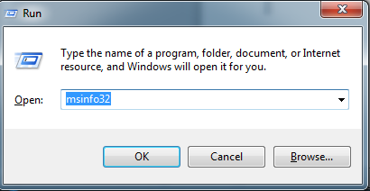

Click OK to launch the system information utility. The highlighted sections in the graphic below for the operating system name, version and system type; (x64 = 64-bit and x86 = 32-bit system)

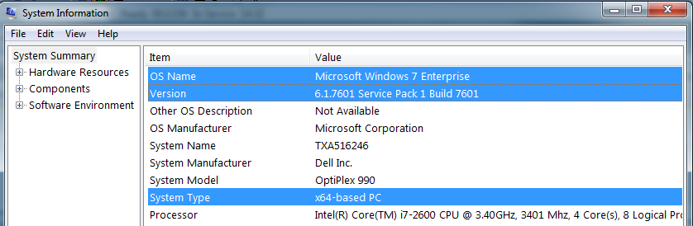

Now you can download the appropriate version of SQL 2008 Express R2 from Microsoft at http://www.microsoft.com/download/en/details.aspx?displaylang=en&id=25174

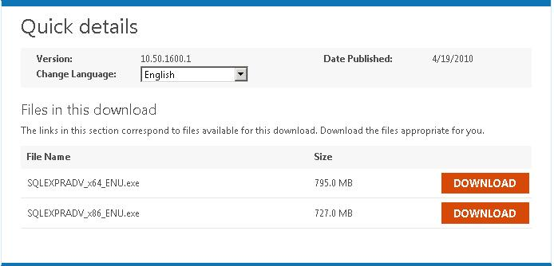

SQLEXPRADV_x64_ENU.exe is for 64 bit computers
SQLEXPRADV_x86_ENU.exe is for 32 bit computers

Click on the download button and save to the computer where the Sage Fund Accounting Server will be installed.

NOTE: You can install the 32 bit version of SQL (SQLEXPRADV_x86_ENU.exe) on both 32 and 64 bit operating systems. The 64 bit version of SQL (SQLEXPRADV_x64_ENU.exe) will install only on a 64 bit operating system.

Please read the entire Microsoft document referenced above at http://www.microsoft.com/download/en/details.aspx?displaylang=en&id=25174, especially if you are using 2003 Server or Windows XP. There are component requirements an older operating system may not have installed. These components include:
Microsoft .NET 3.5 SP1
Windows Installer 4.5
Windows PowerShell 1.0

Installing SQL 2008 Express R2

- Download SQL from the Microsoft site listed above on the computer to be used as the Sage Fund Accounting Server.
- Verify all the necessary Microsoft components are installed. If they’re not, you will receive a message during the installation process telling you the components need to be installed.
- Double-click the download and this dialog box appears, click Run.

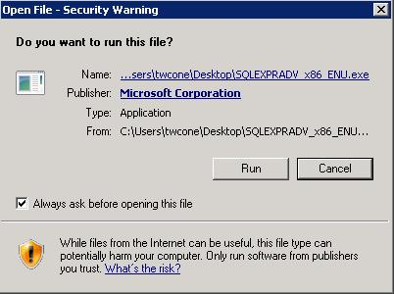

- Files will begin extracting from the download.

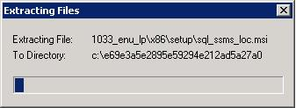

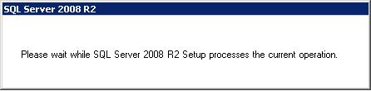

- Then you’ll get the SQL Server Installation Center dialog box.

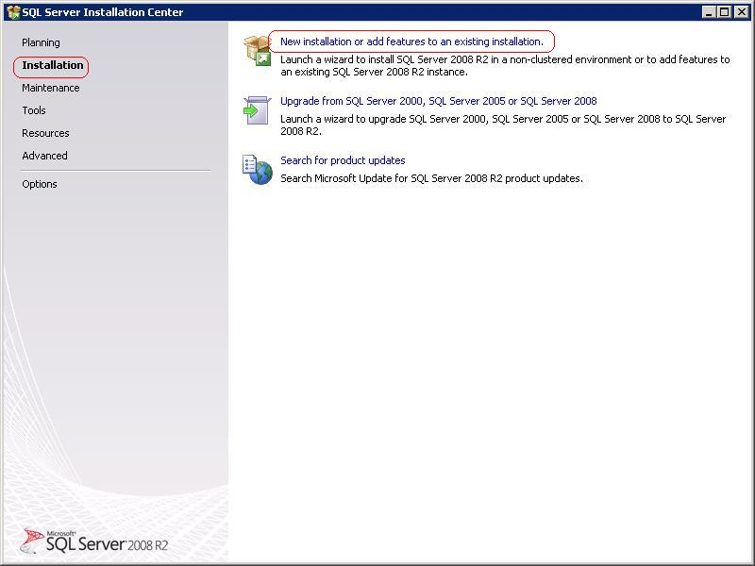

- Click on Installation on the left to be sure focus is on Installation on the left pane, then click the ‘New installation or add features to an existing installation’ link on the right.

- If all necessary Windows components are present, this box will appear.

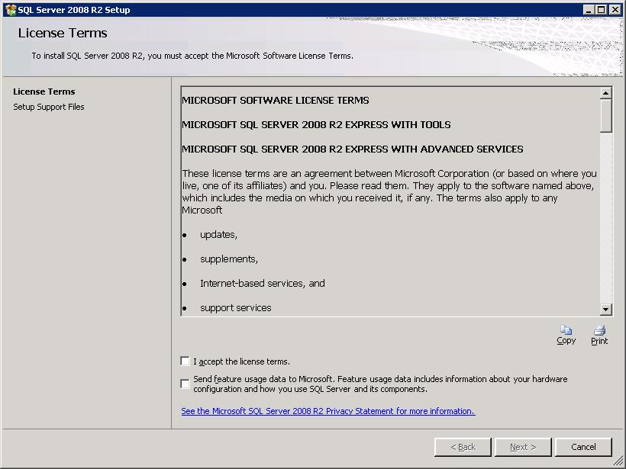

- Agree to the license terms and click Next. The Setup Support Files dialog box appears.

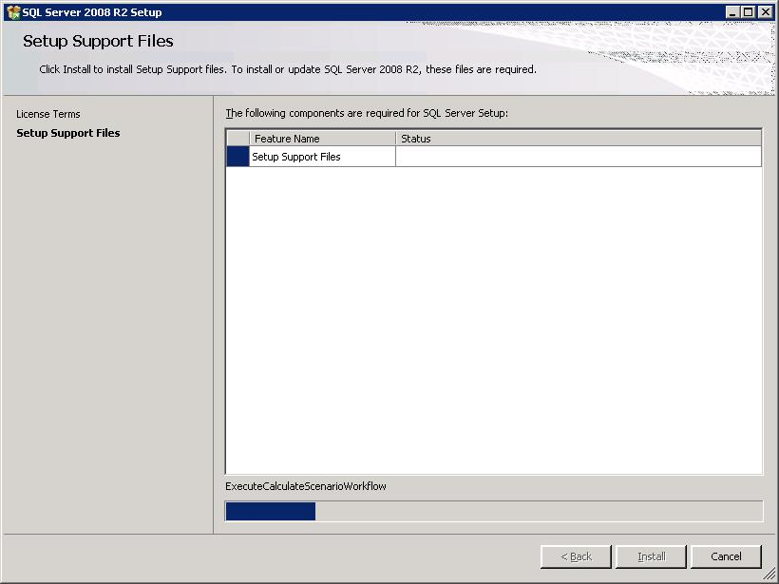

- Your computer may need to reboot later; if so, you will get a message. Click on OK.

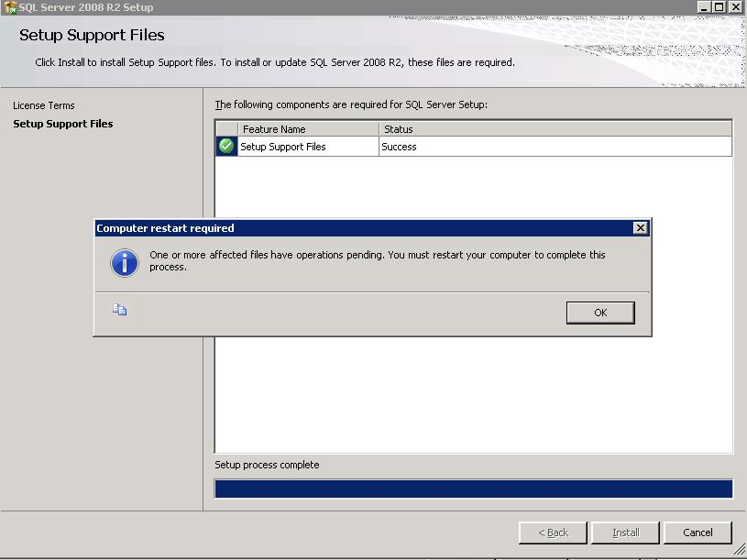

- SQL Server will continue to install.

- Then you’ll be presented with the Feature Selection dialog box where you select which options to install. The options necessary to run Sage Fund Accounting are displayed in the picture below. It will not hurt to select additional components, but they are not necessary and will consume resources on the server. Make the selections listed below and click Next.

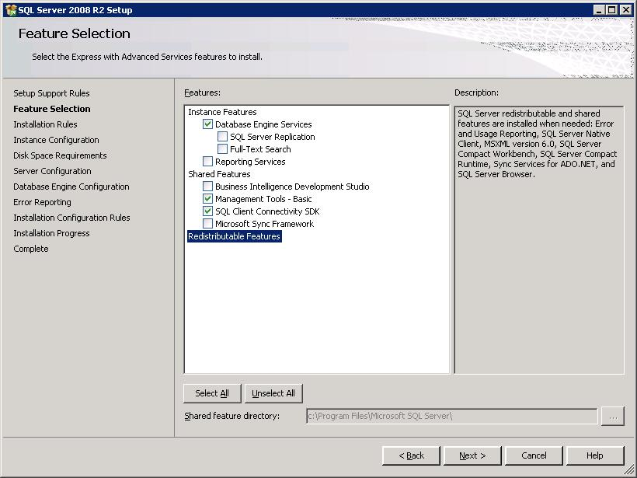

- The Instance Configuration dialog enables you to name the SQL instance and\or install SQL on another drive, if available. There can be only one default (unnamed) instance of SQL on a computer. This option will be available if no other instance of SQL is detected. The default instance will automatically display show as SQLExpress; you can change the name if you wish. Do not use special characters in the name. Once you’ve made your choices, click Next.
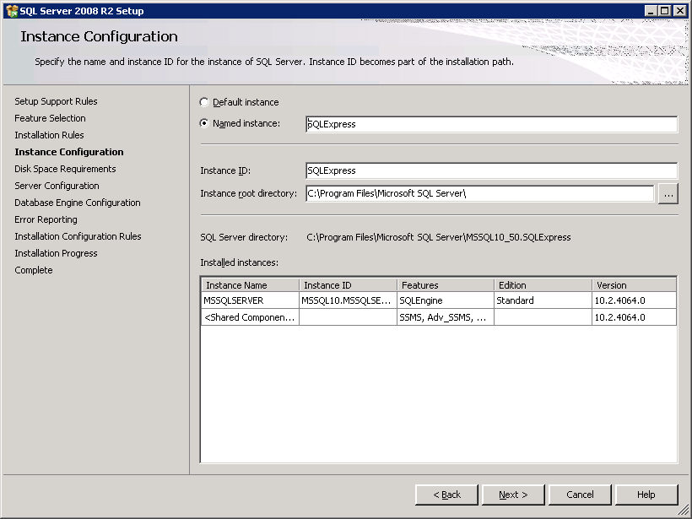

- The selected components are presented – NT Authority is the default. If you choose to select a network user as the account, you’ll need to supply a password. Remember in this case the password will need to be changed in SQL every time it’s changed on the network.

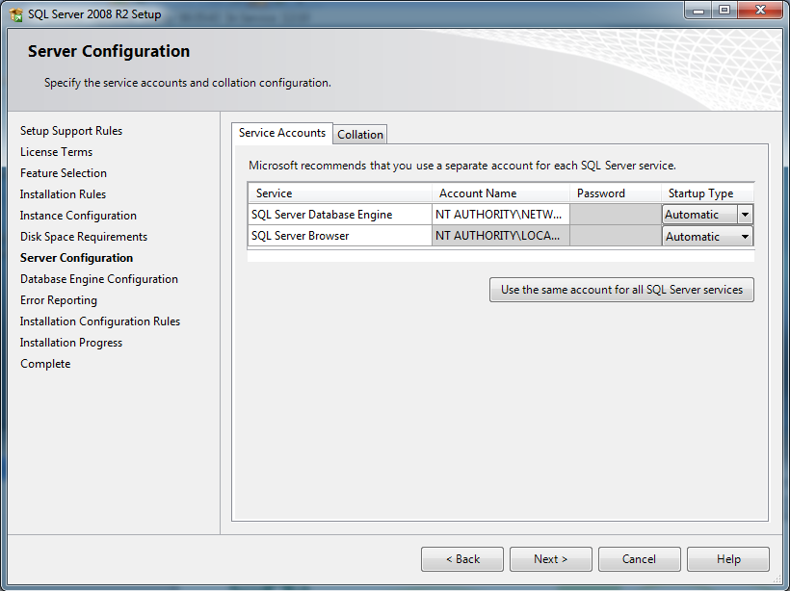

- Do not make changes to the Collation tab. If the collation is changed from the default, the Sage Fund Accounting ‘drill down reports’ will not work. Further, it will require a complete reinstall of SQL to correct this the problem created changing the collation. Click Next.

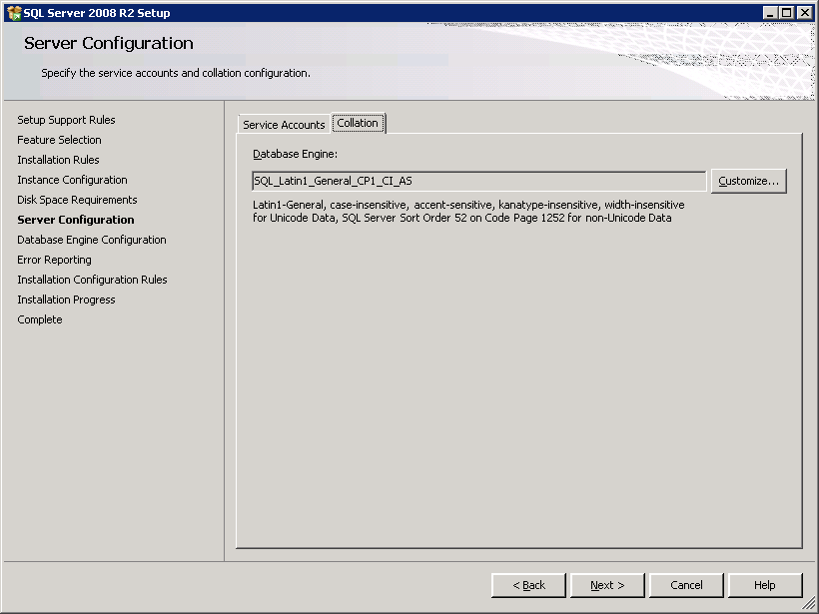

- For Database Engine Configuration choose the Mixed Mode radio button. Enter a password for the system administrator (sa) account in the lines provided. It must be at least eight characters long, one upper case letter, and one lower case letter. In the Specify SQL Server administrator’s box, click on the Add button and add network accounts of anyone who would be administering the SQL Server, if desired. If they are not added here, those users will not be able to log into Management Studio using Windows Authentication. They would be forced to log in using sa and the password you set here. In this instance, the install process added the user I’m logged on as, twcone, and I manually added the user CSA. Click Next.

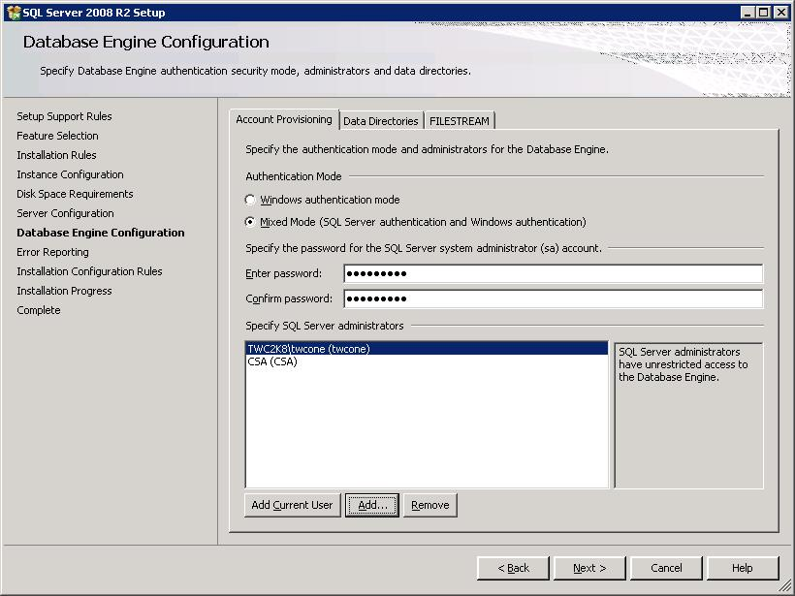

- Select the desired setting for sending error reports to Microsoft and click Next.

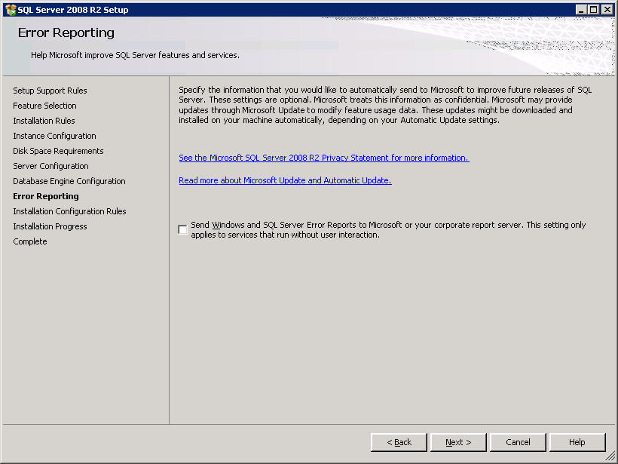

- The installation process will start.

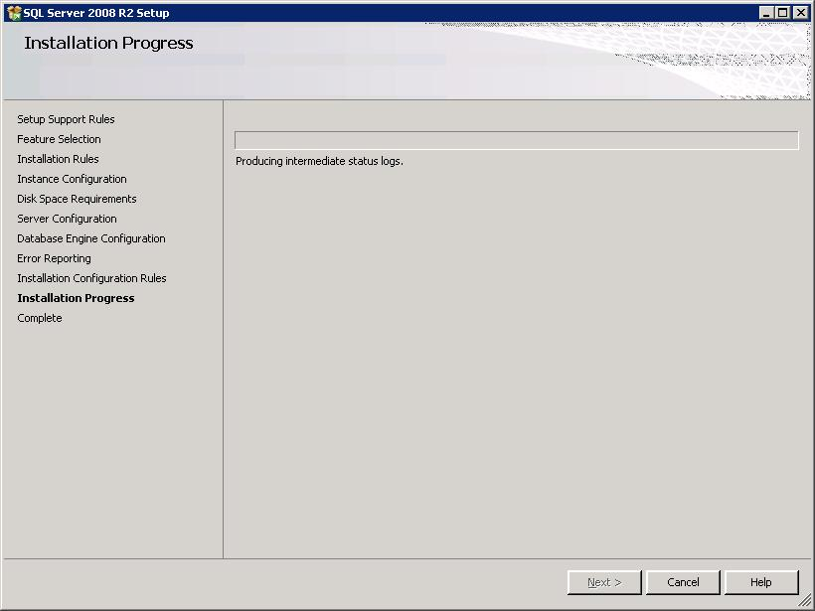

- And continue to install components.

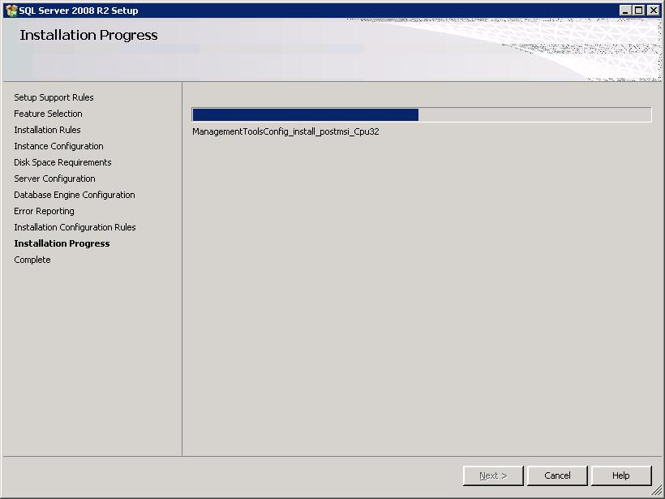

- You will be reminded again that a reboot is required. Click OK.

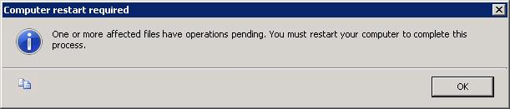

- The Complete dialog box will appear, click Close.

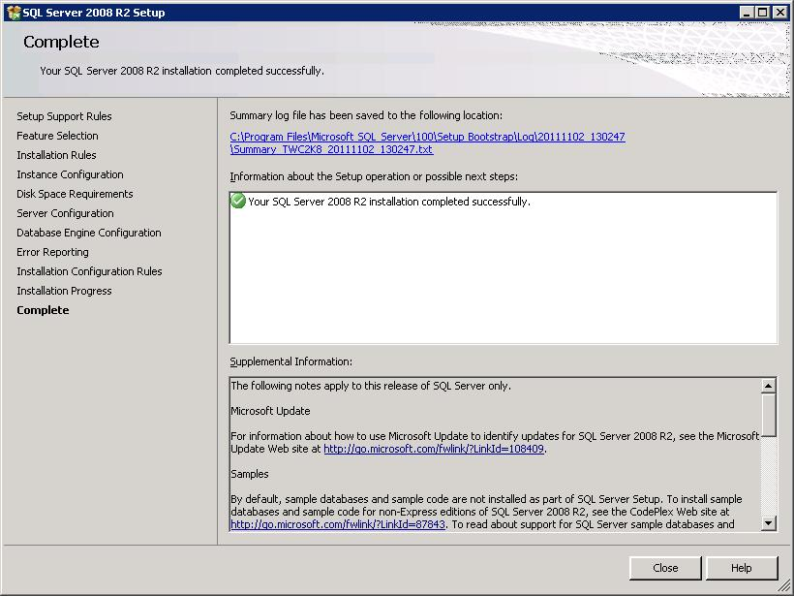

- You will be reminded again a reboot is required.

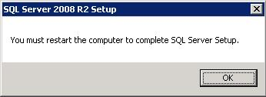

- After rebooting the server, network protocols need to be turned on for the SQL engine. If these are not enabled, Sage Fund Accounting clients on the network will not be able to connect to the SQL Server. Click on Start>All Programs>Microsoft SQL Server 2008 R2>Configuration Tools>SQL Server Configuration Manager.

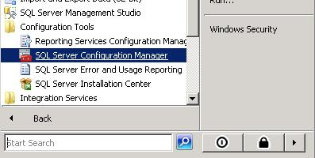

- The SQL Server Configuration Manager will show all SQL instances on the server, be sure to configure the correct one. In this example, we have installed an instance named SQLEXPRESS. Click on that after expanding the SQL Server Network Configuration icon. Note on the right that Named Pipes, TCP/IP, and VIA are disabled. We are only interested in Named Pipes and TCP/IP.

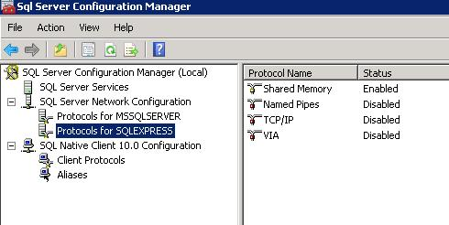

- Double-click on Named pipes and you’ll get the following dialog box.

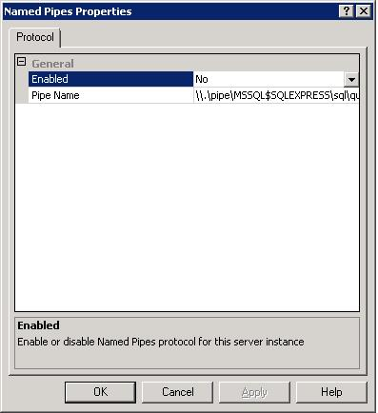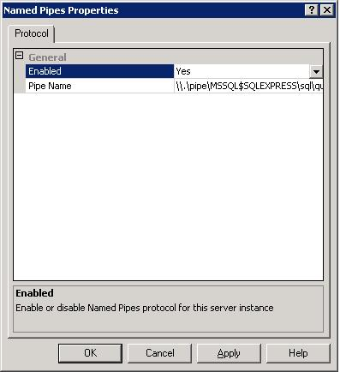

- Click the drop-down by Enabled and change it from No to Yes and click Apply.

- You’ll receive a message stating you must restart the SQL Service for this change to take effect. Click OK.

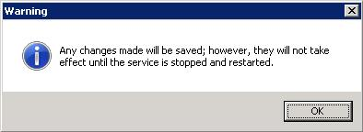

- Follow the same procedure for TCP\IP. Change Enabled from No to Yes and click Apply.

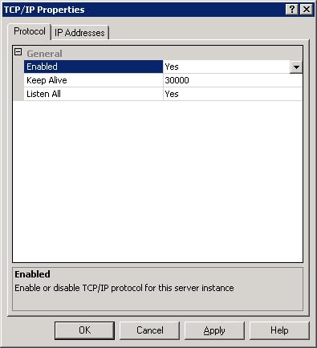

- Click OK to the restart message.

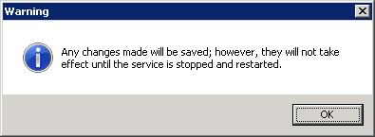

- Now the SQL Server Network Configuration should look like this for the instance of SQL you installed, in this example SQLEXPRESS.

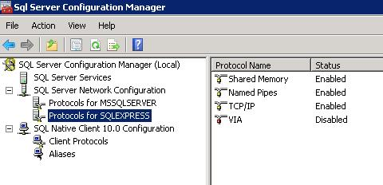

- You can restart the SQL Service for this instance from here without restarting the server itself. Click on SQL Server Services in the left pane. Click on the correct instance of SQL in the right pane – note that SQLEXPRESS is highlighted – then click on the restart button in the toolbar. This will restart the SQL Service for our SQL engine and enable the network protocols we just configured.
- Please note that the SQL Server Browser is Stopped for this scenario which is a stand-alone workstation & server installation. If you are installing to a Server which will have multiple workstations connecting to this instance (peer-to-peer or networked), the SQL Server Browser must be Running.

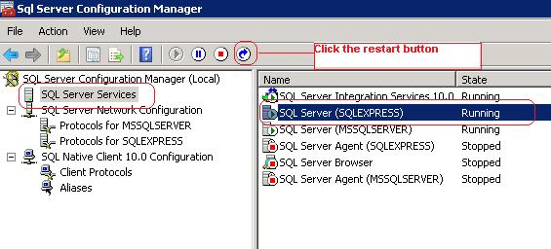

This SQL Server is now ready for production. Launch the Fund Accounting install executable (e.g. FA2013_3_Autorun.exe). Respond with servername\instancename when prompted for the data location. So if your instance is named SQLEXPRESS and your computer’s name is Server100, the appropriate response would be Server100\SQLEPXRESS. The names are not case sensitive.

