Title: Guide to Processing Form 941 with COVID Earnings

Contents
Basic Information 1
The Aatrix 941 2
Getting the Correct Taxable Social Security Wages 3
Getting the Correct Medicare Taxable Amounts 5
Finding Values for Qualified Sick and Family Leave 7
Finding Values for Employee Retention Credit 10
Correcting Schedule B/Box 7 11
Common Issues 13
Q&A 16

Basic Information
Due to legislation from congress in response to the Covid-19 Pandemic Employers can offer their employees leave for COVID related reasons and the government would reimburse them for that leave expense. This reimbursement takes the form of credits towards paid payroll taxes and is reported on the Form 941.

As a result of this there are significant changes to the 941. These changes did not apply to the first quarter. They only apply to Q2-4 of 2020. Baring additional legislation the 941 will revert to back to the way it was in 2021.

There are three aspects of the legislation that affect the 941 in MIP.

1 – Qualified Sick Leave Wages. This is sick leave paid to employees for COVID related reasons. Ideally these amounts would have been set up and tracked separately per KB 24946.
http://kb.abila.com/article/how-handle-covid-19-sick-leave
These amounts will be used in the Worksheet 1 and will carry onto the 941 in a new Box 5a(i)

2- Qualified Family leave wages. This is a variation of FMLA paid to employees for COVID related reasons. Ideally these amounts are set up and tracked in the same manner as the sick leave.
These amounts will be used in the Worksheet 1 and will carry into the 941 in a new Box 5a(ii).

3- There are provisions for employee health care tax credits and the employee retention credit. There were not specific adjustments for those to be done when running payroll, but adjustments will need to be done on the 941 if those credits were taken.

NOTE: Due to the temporary nature of these Changes (Q2-4 of 2020) all processing, and reporting will be handled through the Aatrix 941. The MIP 941 Worksheet (Reports>Payroll>Payroll Tax Worksheets) will not be updated. Because of this the information on the MIP 941 worksheet will be inaccurate if there are any types of COVID earnings. This worksheet should not be used. There are no current plans to update the MIP 941 Worksheet to handle COVID scenarios.

The Aatrix 941

Overview –
To run the Aatrix 941 for Q2-4 of 2020 you will need to do the following:

- Make sure you have the updated Aatrix forms.
- Run a Tax History Report to get the correct amount of Social Security Taxes for Box 5a
- Run a Tax History Report to Verify Medicare Taxes, adjust if they are incorrect.
- Run an Earnings History Report to get the correct values for Qualified sick and Family Leave wages
- Fill out any additional information on the new Worksheet 1.
- Adjust Schedule B for any Tax Credits from Worksheet 1.

Update the Aatrix forms.

To access the Aatrix 941 worksheet go to Activities>Payroll>Tax Forms and Efiling by Aatrix .

If the form updates button is available press it to make sure you have the latest updates.

NOTE: The updated 941 for Q2 will not be available until after 6/30/2020. Make sure you select the proper quarter and year as the 1st quarter worksheet is different.

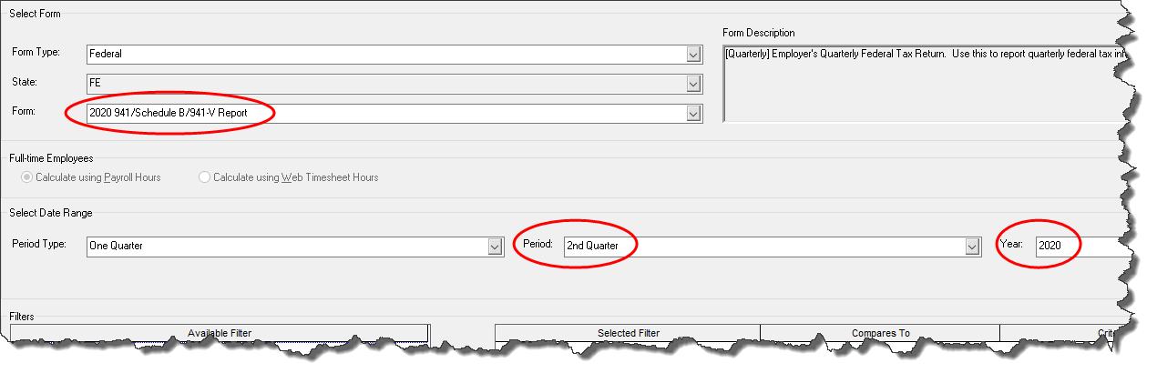

Click Ok at the bottom and that will bring up the 941 Worksheet.
You should take some time to time to review the new worksheet. It has more pages.
Take note of the new sections 5a(i) and 5a(ii). In addition there is a checkbox to bring up the new Worksheet if you do not have the new 5a wages.

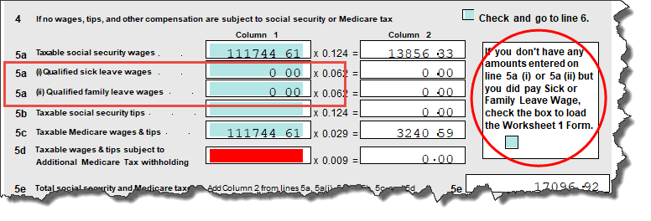

If you have COVID related earnings these values need to be added in. There is no function within MIP to automatically pull these values in the 941.

Getting the Correct Taxable Social Security Wages

If you had employees with COVID earnings it was recommended that each payroll you go into Review/Modify Calculated Payroll and adjust the EMPLOYER subject earnings and Taxes to zero for those COVID earnings.

http://kb.abila.com/article/how-handle-covid-19-sick-leave

If this was done when you pull up the 941 the amount that MIP Is pulling into the Taxable Social Security Wages (Box 5a) will not be correct and has to be reduced. This is because MIP passed the employee subject earnings to Aatrix, not employer subject earnings. The amounts in this box should be the employer subject earnings. This means you need to run a report and found out what the Employer Subject Earnings should be and put that value into box 5a.

To find this amount you can run a Tax History Report. Go to Reports>Payroll>History>Taxes
Create a new report and make sure the dates are correct for the time period in question.

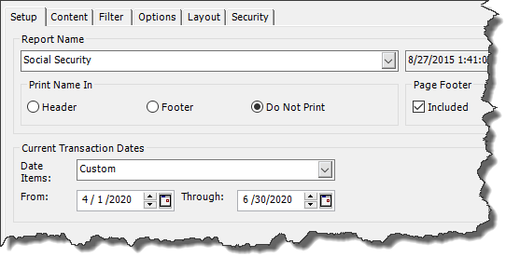
On the content tab use the following items in Selected Columns
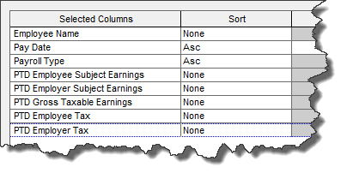
On the filter tab choose Tax Type = SS

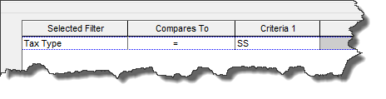
Run this report and it will give you a summary of all the social security taxes

You should look for the total under the column
PTD Employer Subject Earnings.

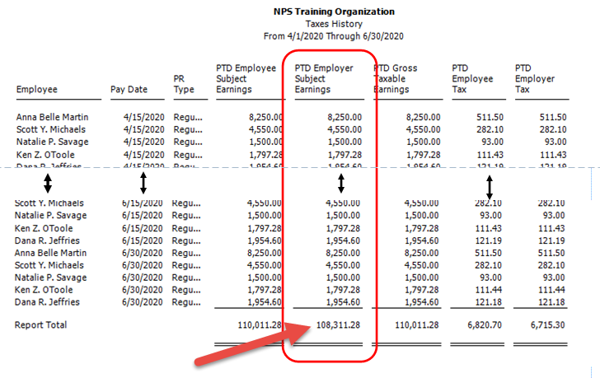

Take this total and type it into the Box 5A Taxable Social Security Wages

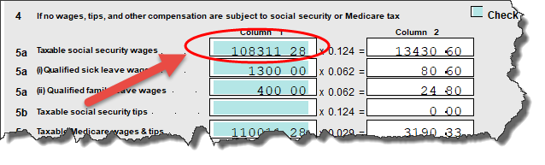
NOTE: Taxable Social Security Wages may be modified if you have values on Step 3 of the Worksheet 1 of the 941. This section deals with employee retention credits. You should consult your Tax Advisor about the effect of these on your 941.

Getting the Correct Medicare Taxable Amounts

Early guidance on the treatment of Medicare Wages with COVID earnings was confusing and not clear. It seemed to indicate that they were to be reduced like Social Security Earnings (reduce Employer subject and Employer Taxes to zero). Subsequent guidance and clarification indicate that this not the case. If you think that Medicare might have been adjusted, then it is a good idea to run a Medicare Tax history report to find out, and if needed make adjustments.

If you do not think your organization did this, then you can skip this step. However, if you find you have unexpected values in Box 7 at the end of the 941 process you should probably run this report to make sure this is not the issue.

To run the Report, use the same report setup that you did for Social Security Taxes above but change the filter to be Medicare.

When you run the report look at the bottom line to see if the PTD Employer Subject Earnings = PT Employee Subject Earnings and if the PTD Employer Tax = PTD Employee Tax.

If they do not chances are adjustments were done unless you have someone that earns more than 200K.

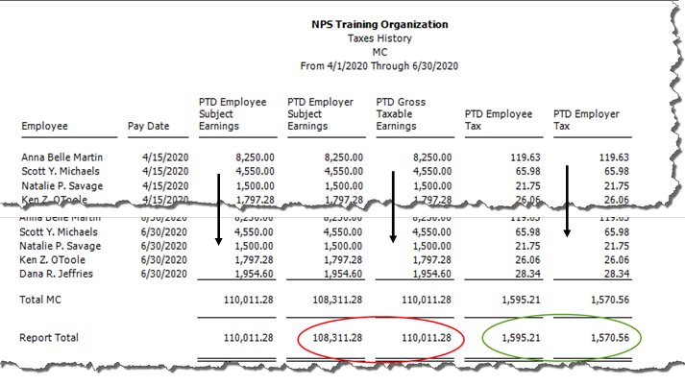

If you do find the there are differences between the employee and employer amounts for people making less than $200K then those should be fixed. Look through the report for employees that have a difference. If the difference was because of treating Medicare like Social Security for adjustment purposes, then you will see employees with $0 amounts in the Employer Values.

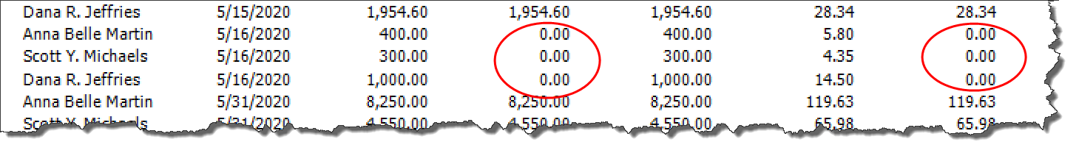
To fix this go into Activities>Payroll>Setup Adjust Employee Balances. Make and adjustment for each employee. You can adjust this on a period by period basis or do one summary adjustment at the end of the quarter. The amount of the adjustment should be what is required to bring the Employer amount to be equal to the Employee amount.
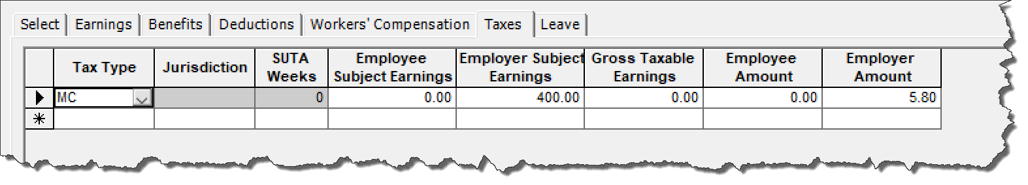

Once this adjustment is done rerun the report to confirm that the amounts are equal.
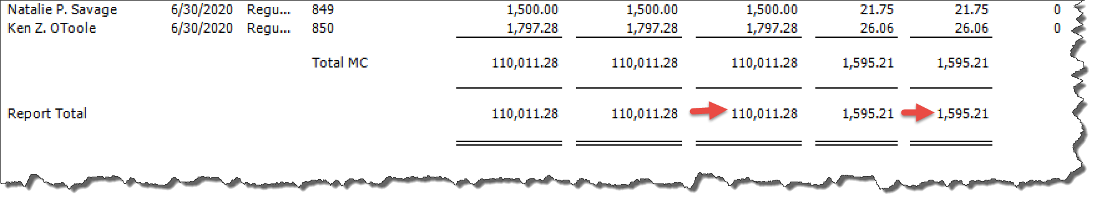

Finding Values for Qualified Sick and Family Leave

If payroll is set up as recommended you can run an Earnings History Report to get the amounts that were coded to the various COVID earnings.

To do this go to Reports>Payroll>History>Earnings.
Create a new report called COVID.
Set the date range for the quarter you are running the 941.
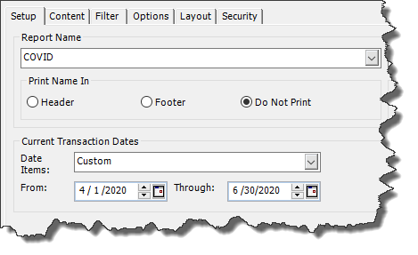

For the Content Tab use the following columns in Report Body
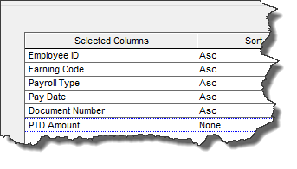
On the Filter Tab Filter on the Earnings Code you used for each of the earnings. If you set up 3 earnings codes, you will run the report 3 times.

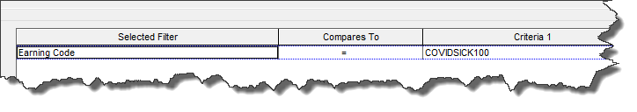
When you run the report, you will get the detail and total amount of earnings for that earnings code.

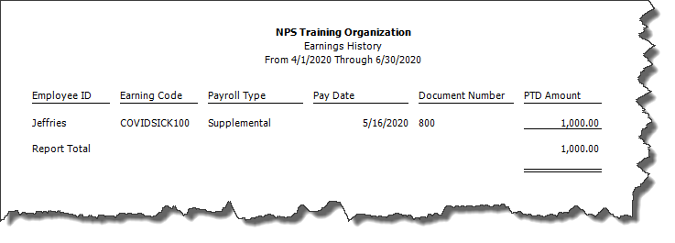
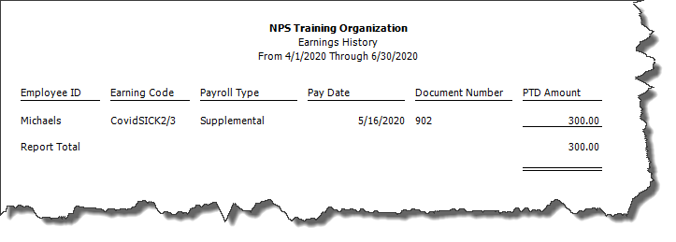
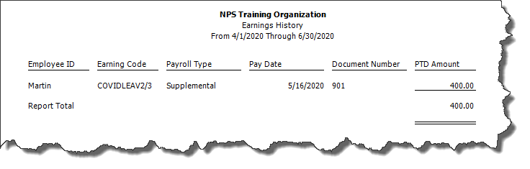

Add all the earnings code used for Sick Leave (Sick100 and Sick2/3 in this example) together and put that amount in box 5a(i).
Add all the earnings code used for Family Leave (CovidLeave2/3 in this example) together and put that amount in box 5a(ii).
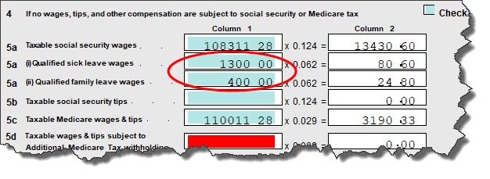

NOTE: If this is the first time to put a value into either of these boxes it will automatically take you to Worksheet 1 to put the information in. The amount of COVID sick pay (total for all codes) goes into Box 2A. The amount of COVID FMLA (total for all codes) goes into Box 2E.

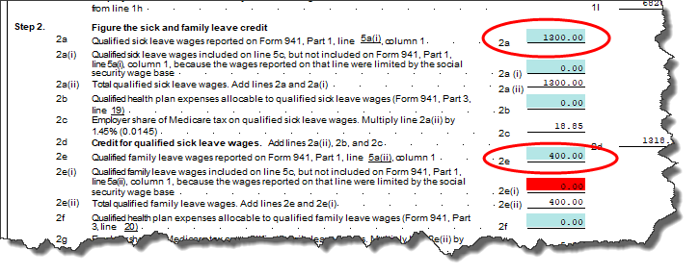

You can use the page navigator at the top to return to any page the form or get back to this worksheet.
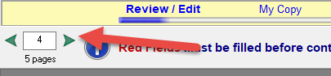

There may be additional information you need to fill in on this worksheet based on your tax situation. But 2a and 2e were the only boxes that MIP has specific tracking recommendations for. There is not a specific recommendation on how Part 3 Information was recorded so you will need to pull the information based on the way that you recorded it. Some customers created unique Benefit Codes. If that is the case a benefit history report like the earnings history report would be useful.

For more information on the new 941 Worksheet 1 consult the IRS for instructions.

Finding Values for Employee Retention Credit

In addition to the Sick Leave and FMLA the government implemented two programs. An employee retention credit which helped pay a percentage of qualified wages or the Paycheck Protection Program which was a qualified possibly forgivable loan/grant. These were an either/or selection, you could not take both.

Due to this and the complexity of these issues we do not have any guidance at this time about how these should be recorded in MIP or what qualifies to go in this part of the worksheet.

When you get to the 941 on the Worksheet 1 there is Step 3 which addresses the Employee Retention Credit.

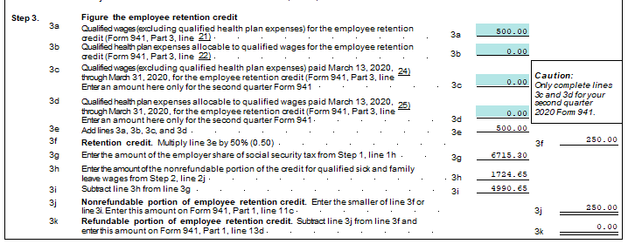

If amounts are put into Section 3 half of the amount put in will show up as a credit on Part 1 line 11C. This will require you to adjust Schedule B.

Correcting Schedule B/Box 7

If the organization is a semiweekly depositor go to page 2 of the 941 and check the appropriate box at the bottom of the form in Part 2 (it has moved). When you do this, it will enable Schedule B.

Schedule B is the actual amounts of tax withheld for FIT, SS and MC for the employee and employer.
If you followed the setup for COVID earnings this amount should already be reduced by the employer share of SS taxes for COVID earnings.

After you have corrected all the Box 5 amounts and filled in Worksheet 1 it is very likely that you will see an amount in Part 1 Box 7 Fractions of Cents. This is the difference between the calculated liability and the amount of tax withheld on Schedule B. Normally this value should be less than $1 from rounding issues.

If all adjustment and entry were done correctly the amount in this box will be equal to the tax credit that has not yet be taken for the various COVID programs. The amount should equal the amounts in Box 11B and 11C.

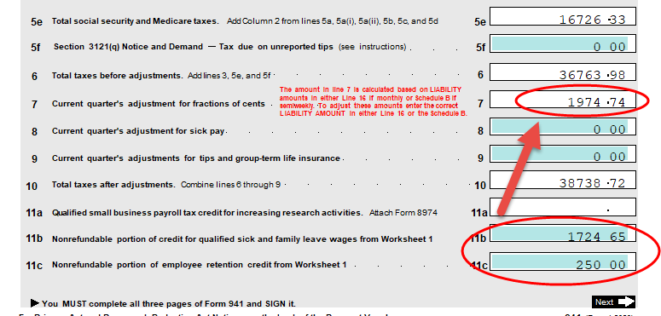

If it does not you should review the Social Security and Medicare Tax history reports to make sure the information is correct as well as the adjustments for Box 5 and the Worksheet.

If the amounts do tie, then the final step is to do an adjustment of the 941 Schedule B. Using the page arrows up top go to the 941 worksheet (Page 5). You will see amounts on different fields. This represents the actual amount of tax collected on each day of the month. The tax credit needs to be applied to one or more of these fields.

The easiest thing to do would be to find a single field that is large enough to be reduced by the amount of the tax credit without going negative. Subtract the amount of the tax credit (current box 7 amount) from this field. This is adjusting down the amount of tax collected to reflect the credit.

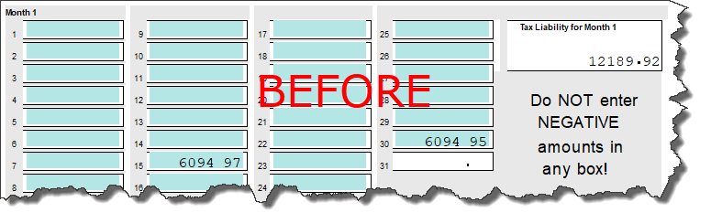
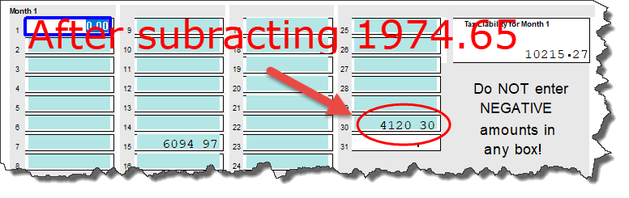

If you do not have a single field that is large enough to absorb the amount of the adjustment without going negative (going to zero is ok) then will need to spread the amount among multiple fields reducing them as needed until as a whole the entire worksheet will be reduced by the correct amount.

DO NOT attempt to put a negative amount in any field, it will not carry forward properly.

Once this adjustment is made Box 7 should be less than $1.
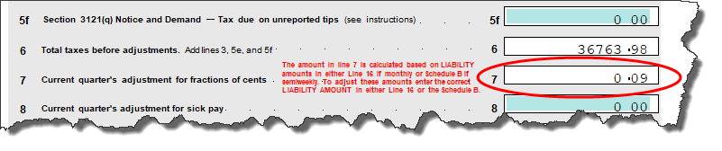

Common Issues

The COVID related legislation was hastily passed and it was some time before the IRS had proper guidance on exactly how it was supposed to work. In addition, properly recording COVID taxes is a manual process in MIP which can lead to mistakes.

Below are common errors and their solutions:

Error #1 – Wages were not classified under a COVID earning code.
If the COVID code was not set up or used consistently for the entire quarter the COVID wages will be understated. When you run your Earnings History Report it will not be correct. There is no way for the system to know if the wages are correct or not, you will have to analyze the Earnings History report to see if people were properly included.

If you discover that some wages were not included, then they can be adjusted. This assumes the wages were paid, just not under a COVID earnings code. If this is the case, you can either manually add them into the report or do an adjustment to correct them.

To do an adjustment go to Activities>Payroll>Setup/Adjust Employee Balances.
Select the employee that is missing wages. The adjustment date should be the pay date it is missing from if you wish to correct payroll by payroll or you can do a summary adjustment for the entire quarter on any of the pay dates.

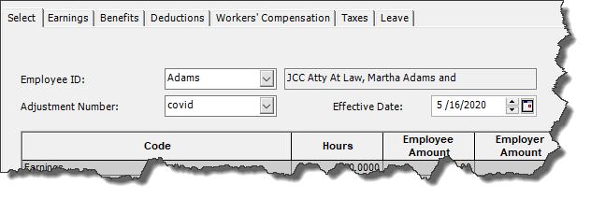
Go to the Earnings Tab.
On the earnings tab decrease the earning code that was improperly used for COVID wages.
Put the COVID earnings code on and increase it by the amount the other code was decreased.
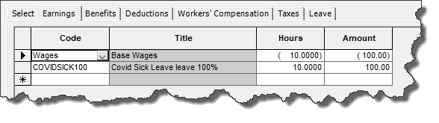
NOTE: Adjusting earnings DOES NOT adjust tax amounts.

Error #2 – Social Security Taxes are Incorrect
To get the correct Employer Subject Earnings and Employer Tax, users had to go into Review/Modify Calculated payroll and manually adjust. Then save it without recalculating. Its possible a mistake occurred in the process and the Social Security taxes are incorrect.

Review the Social Security Tax History report that was run to determine the value in Box 5A. If the value does not add up to what is expected look for employees that have odd values. Things to look for:

-Employees that had COVID earnings, but the Employee and Employer Subject Earnings and Taxes are the same.

-Employees that did not have COVID earnings but have different Employee and Employer Taxes.

-Employees that had a combination of regular and COVID earnings that seem to have an incorrect amount of employer and Subject Earnings and Tax.

If you find an employee with this problem, it can be fixed via Setup/Adjust Employee balances.

You would make an adjustment like the one in previous setup, but you would make it on taxes tab.

If the amount of Subject Earning and/or Tax for the Employer portion is too high you would do a negative adjustment to taxes by the amount it is to high. For example, if it is $700 and it should be $600 you would do a -$100 adjustment.

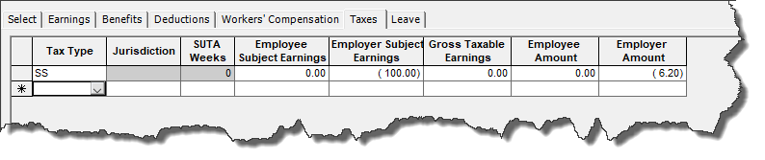
NOTE: If you are doing a negative adjustment it is important that it be done on the same date the tax was recoded in. If you do a negative adjustment without a positive amount to match it against it will not pull into Aatrix properly.

If the amount of Subject Earnings and/or Tax for the Employer portion is too low, you would do a positive adjustment for the amount it is too low by. For example, if it is $600 and it should be $620 then you would do a +$20 adjustment.

Error #3 - Medicare Amounts are Incorrect.
Early guidance on the tax treatment of COVID earnings indicated that Employer Medicare subject earnings and taxes were affected by the credit like Social Security. Further clarification indicated this was not the case. Before that was clarified customers may have treated it like Social Security and reduced taxes. If this is the case, then Box 7 amounts will be incorrect because the employer tax amounts are not part of schedule B. To troubleshoot this run a tax history report similar to the Social Security Tax report listed above. Once you find the employees with the incorrect values you can make adjustments accordingly. While it is possible to simply adjust Schedule B adding the amount of tax back on this may cause reporting complications when trying to calculate excess Medicare Withholding for high income employees.

Error #4 – Box 7 Amounts incorrect.
For customers that are semi-weekly depositors you will continue to check the semiweekly schedule option on page 2 of the 941. When you do this, it will enable Schedule B as well as put amounts into Box 7 on Part 1. Box 7 is the difference between what is calculated to be withheld based on statutory percentages and what was actually withheld on the schedule B. Normally this would be just rounding differences (less than $1). However, if any of the adjustments were not done correctly that amount may be a large number. If that is the case additional adjustments need to be made.

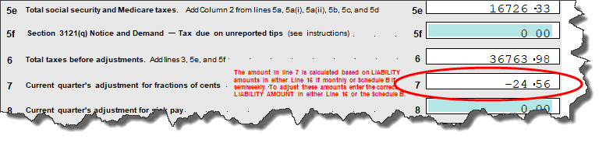

Here are some things that are common causes of Box 7 having large values

- Box 5A has not been reduced by COVID earnings. Review the section in this document that discusses how to proof those amounts.

- Box 5A(i) and 5A(ii) do not have the correct amounts in them. Review the section of this document that discussed how to proof those amounts

- The amount of SS and/or MC tax withheld was not correct.
Most of the time this is because of a mistake on an adjustment. Because if this the amount of actual tax withheld is not the same as the percentage amounts that are calculated based on subject earnings.

To proof this, review the session on proofing the SS taxes and Medicare taxes. Most mistakes stem from errors where subject earnings and taxes were not reduced in sync (typically one or the other). Also look for adjustments. Many times, adjustments do not adjust both subject earnings and taxes in sync.

- There are amounts in Part 3 (Employee Retention) that require additional adjustments on the 941. If you put amounts on the Worksheet in Part 3 you will need to adjust Schedule B.

Q&A

Q: Is it possible to have MIP pull the correct SS Tax information into Box 5 without running a report?

A: No. MIP looks at Employee Subject Earnings vs Employer Subject earnings because it must use the same data gathering process for individual tax forms like W2s.

Q: Is it possible to have MIP automatically pull amounts into Box 5a(i) and 5a(ii) without having to run a report? Is this going to change for future quarters?

A: No, we do not have the ability to tag earnings to affect taxes in the proper fashion. Programming changes were considered but due to the temporary nature of this change and the amount of re-writing of core tax calculation processes that will not be changed unless additional legislation comes out making this a permanent change.

Q: When I do adjustments for the Tax Credits on Schedule B can I make a lump sum adjustment? Which period would it go in?

A: You can make a lump sum adjustment to any period in the form as long as the amount after the adjustment is not negative. If you wanted to break it out period by period that is also acceptable.

Q: What if the amount of my adjustments to Schedule B would result in a negative value overall (adjustments are greater than amount of tax collected).

A: Adjust the values down to zero, you will need to put the remaining value elsewhere in the 941 as a credit amount. You should consult your tax advisor about this scenario.

