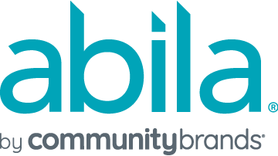

Cloud

Administrative Request Authorization Form

(Chargeable Requests)

Disclaimer
Please note that a Support case needs to be established prior to submitting this form. Please contact Community Brands Support at 800-945-3278 to create a case which needs to be indicated in the field below.

Case Number:

Before this request will be processed, I understand that a Community Brands Customer Support Analyst must first verify that I am an Administrator in the hosted application. This validates my authority to make this request. Thank you.

The purpose of this form is to authorize Community Brands to process chargeable administrative requests for your Abila product. This authorization is intended to protect the security of your system. Please fill in the information below.

Hosted Product: Organization Name:

Serial/Account #:

Restore database from backup*. The organization database name is .
Please specify the date and the time to which you want your data restored (i.e. how far back do you want to go?): Date: Time: Central Time

*Customer is allowed one (1) free local restoration event per calendar month and one (1) free offsite restoration event per calendar year. Charges for additional local restoration events will be assessed in 1-hour increments at a rate of $165/hr with a 1-hour minimum. Charges for additional offsite restoration event will be assessed in 1-hour increments at a rate of $165/hr with a 2-hour minimum.

Request a current backup copy of organization database(s)**. The organization database name(s) is/are: .

Alternatively, if you would like a current backup copy of your organization database to be sent to your channel partner or to a third party, please provide email address of said party.

Any backup copy is sent electronically through a secure connection
**Customer is allowed one (1) free backup copy of a single organization database per calendar month. Charges for additional backup copies or separate organization database(s) will be assessed in 1-hour increments at a rate of $165/hr with a 1-hour minimum.

Community Brands has estimated that the total time is hour(s). The total charge for the requested services is $ , plus any applicable sales tax.

I understand that after restoring an organization database from backup, any data entry since the date and time specified above will be lost. It is my organization’s responsibility to re-enter any lost data.

By signing this document, I authorize Community Brands to process the administrative requests on this form.

Authorized Signature: _____________________________________ Date: _______________

Printed name: Title/Position:

