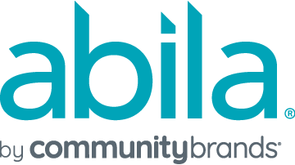

Cloud

Administrative Requests Authorization Form

(chargeable requests)

For Girl Scouts National and Councils Only
****Disclaimer ****
Please note that a Support case needs to be established prior to submitting this form. Please contact Community Brands Support at 800-945-3278 to create a case which needs to be indicated in the appropriate field below.

Case Number:

Before this request will be processed, a Community Brands Customer Support Analyst must first verify that the requestor is an Administrator in the hosted application. This validates that the requestor has the proper authority to make the request. Thank you.

The purpose of this form is to authorize Community Brands to process chargeable administrative requests for your Abila Private Cloud product(s). This authorization is intended to protect the security of your system. Please fill in the information below.

Council #: Council Name:

Restore database from backup*. The organization database name is: .

Please specify the date and the time to which you want your data restored (i.e. how far back do you want to go?): Date: Time: Central Time

*Each Girl Scout council is allowed two (2) free local and one (1) offsite restoration events per calendar month. Charges for additional restoration events will be assessed in 1-hour increments at a rate of $165/hr with a 1-hour minimum.

Request a current backup copy of your organization database(s)**. The backup copy will be sent electronically through a secure connection.

The organization database name(s) is/are: .
**Customer is allowed one (1) free backup copy of a single organization database per calendar month. Charges for additional backup copies or separate organization database(s) will be assessed in 1-hour increments at a rate of $165/hr with a 1-hour minimum.

Community Brands has estimated that the total time for all requested services is hour(s). The total charge for the services is $ , plus any applicable sales tax.

I understand that after restoring an organization database from backup, any data entry since the date and time specified above will be lost. It is my organization’s responsibility to re-enter any lost data.

By signing this document, I authorize Community Brands to process the administrative requests on this form.

Authorized Signature: _____________________________________ Date: _______________

Printed name:

Title/Position:

